Semi-conductor Basics: What are they and how do they work?
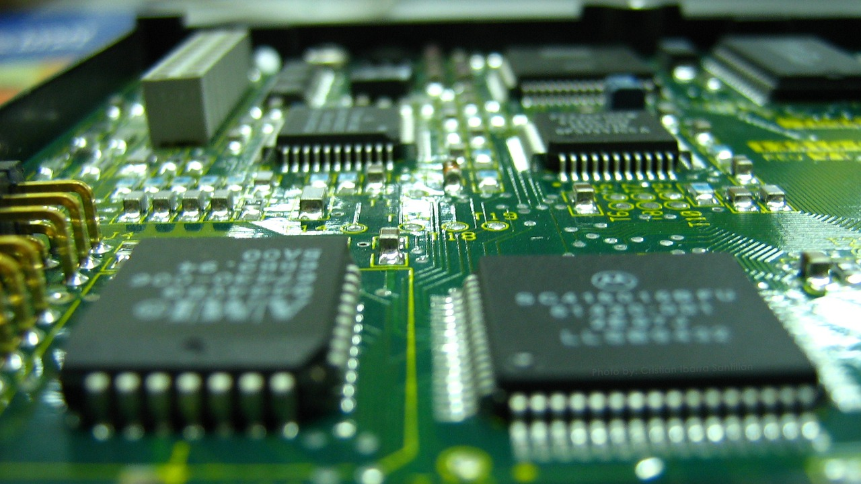
Photo by CristianIS https://pixabay.com/users/CristianIS-2094012/ on Pixabay https://pixabay.com/illustrations/microchips-electronics-semiconductor-4924170/
‍
Electricity hates semi-conductors because current can only travel through them when you tell them to or more specifically, when you turn a switch on or off. It’s similar to driving a car. You can’t just drive freely down the road and think there will not be any controlling devices such as a red light or stop sign along the way. If your car is the current and the road is the semi-conductor, you are moving the current as you drive along the road. Now picture a light bulb at the end of the road. If the current continues to run (your car is driving), you will reach the light bulb and voila! You just lit the bulb with the electrical current that flew through the road.
But what if there was a stop sign in the road? You must stop the car (stop the flow of current) and then there is no voila. The bulb will not light because no electricity was allowed to continue to flow through the road to reach it.
A better analogy is when you turn on the faucet to allow water to flow. When you are done, you turn it off and the water stops flowing, but you can also control the speed or force at which the water comes out. It is this force that would be equate to voltage when speaking about electricity. So the way the flow of electricity is controlled through the semiconductor is by controlling the amount of voltage that is being used. If too little voltage is sent through, then no electrical current will travel through, but if you raise the voltage, it will trigger the material to open and allow the current to flow through.
This control of whether current flows or doesn’t flow through the semiconductor has a name – transistor, which is nothing more than a switch to allow or disallow electricity to flow through the conductor, and as mentioned above, the transistor will open when a certain amount of voltage is used but will close when not enough voltage is used. Transistors are plentiful in the computer environment. There may be thousands of them on one computer circuit board. Transistors are integrated onto a computer chip, like the ones shown in the photo above.
These on and off states in the transistors create logic which allows the computer to decide what to do or not to do to get the desired result, but we don’t call them on or off states. Instead, we represent them by numbers. ‘1’ represents on and ‘0’ represents off, which in computer talk are called bits. For example, if a pattern of eight bits is aligned together where some are set to ‘1’ and others are set to ‘0’, this would tell the computer to do something. What it would do would be dependent upon the particular pattern of ones and zeros. If you are thinking this seems like some type of code, it is and is called binary code. Whenever you have eight bits aligned together, they are called a byte. An example would be a sequence of these bytes, maybe 10 to keep things simple, and each set of bytes have a particular arrangement of bits that are either on or off could be telling the computer to print a document.
Our article on how bits and bytes work with computers explains this in more detail.

What are Semiconductors Made Of?
Transistors are made of silicon and germanium, an element typically found in sand. The physical characteristics of silicon and germanium can be perfect conductors to allow current to flow without much resistance, but can also be perfect insulators to stop any current from flowing, which makes it a truly superior mineral when you need to control electricity.
Summary
Transistors allow current to flow or not to flow through it. The material that the current resides is silicon, which is used because its properties allow it to work well as a conductor but just as well as an insulator. Each on or off state is represented by a ‘1’ or ‘0’ and is called a bit. Eight bits make a byte, and it is the particular pattern of bits in each of the bytes that determines a certain instruction for the computer to follow.

